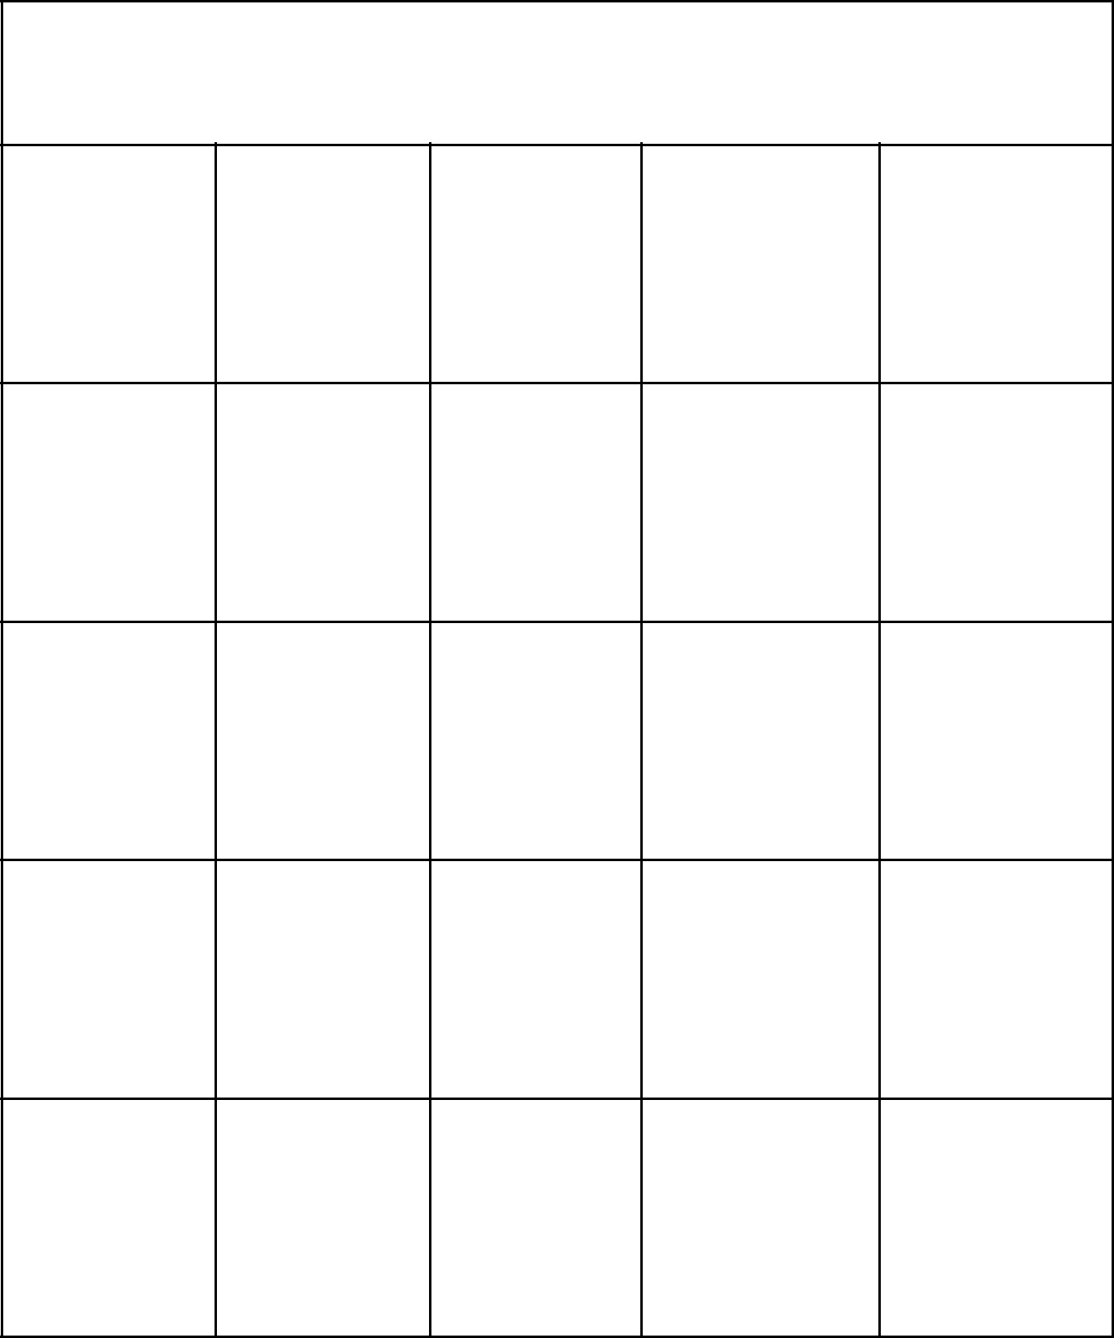**Schechter Experiences Bingo**

|  |  |  |  |  |
| --- | --- | --- | --- | --- |
| Reading | TKAMB 8th Grade | LA | Yom |  |
| Torah | Ha’Atzmaut |  |
|  |  |  |

|  |  |  |  |  |  |
| --- | --- | --- | --- | --- | --- |
| 8th Grade | Schechter | Physics | The | JS |  |
| Shabbaton | Bucks | Outsiders |  |
|  |  |  |

|  |  |  |  |  |
| --- | --- | --- | --- | --- |
| Wrap and | World | **FREE** | Kindergarten Gym |  |
| Strap | Wars | **Free Space** |  |

|  |  |  |  |  |  |
| --- | --- | --- | --- | --- | --- |
| Tikkun |  |  | Pretzels | Ultimate |  |
| Science | Tribes | From The |  |
| Ceremony | Frisbee |  |
|  |  | Nurse |  |
|  |  |  |  |  |

|  |  |  |  |  |
| --- | --- | --- | --- | --- |
| Hot Lunch Hebrew | Touching | Gidwitz | The Pizza |  |
| The Lights | Eater |  |
|  |  |  |



**Schechter Experiences Bingo**